Lab 02 - MIRA  
Probabilistic Atlas

Overview

The lab is composed of two parts, Registration and building the Atlas. Registering with all its details is crucial for a good segmentation. Later different approaches with Atlas will be tested, and we will try to discuss the problems and workarounds to achieve perfect results .

Registration

**Manual:**

File in MATLAB:

preRegistration.m : used to choose the right reference, we can modify it the way we want depending on the metric we use .

postRegister.m : used to test the quality of our registration

Register.m : in this code Images were registered to create the atlas from later. The results are saved in a directory named result in the same path of code.

probAtlas.m : the code creates the atlas and saves copy of files of the atlas each one alone to be used later with registration since registration is a command line tool and reads its inputs from files. The files named label1 correspond to class1 .. Also files ending with ‘_’ means that those files were normalized to a maximum intensity 15000 ( this is needed in registration) and then normalized back to a probability value after the corresponding registration.

**Registration Settings:**

Parameters Source: <http://elastix.bigr.nl/wiki/index.php/Par0000>Registration is formed of an affine transformation that uses a Multi Resolution Registration of 4 levels and a maximum of 500 iterations per level, followed by a non rigid bspline transformation. We use the masks for both fixed and moving Images.

It is worth to mention that couple of settings were tried out before, but the results were very bad ( Fig 1. ).

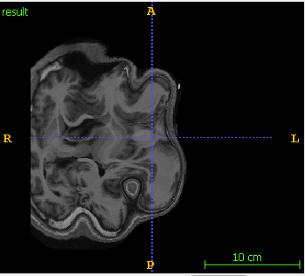

*Fig 1.* Param0009

**Choice of reference:**

Although none of the methods can guarantee a good candidate for registration, but we wanted to take the best approach. The problem is not only in performing good registration, for example perhaps we might choose a reference with pathology and then end up moving all images to this wrong reference. We could have tried all possible references ( in our case 15 ) and check the one that is near to all, but then this can guarantee a good registration but not a good reference to be taken . Also we considered that it may be that in reality we don’t have that number of ground truth so what we are doing comparing the images (Intensity images not the ground truth ) to all images in our data, and the one with more similarity it is to be chosen , this way we can at least somehow guarantee that the chosen image is not a pathology.  
Because we are comparing Images before registration, SSIM similarity is to be used .

Again this choice may be right or wrong, but always better than random selection.

The results below ( *Fig 2.* ) show the mean in the first row , standard deviation in the second and the index of file in the third.

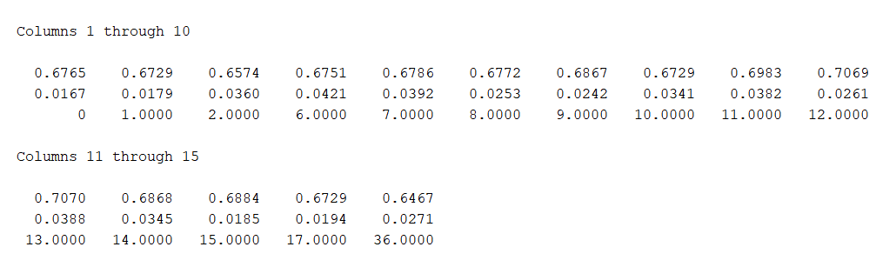   
*Fig 2. pre-Registration analysis*

We can see that file 12 in column 10 has the best result ( although it is a slight difference ), also when testing the labels in the same manner, the results showed Image 12 wit the best result.

**Results:**

Quantitative:

We can see that the similarity has increased from 0.7 to 0.82

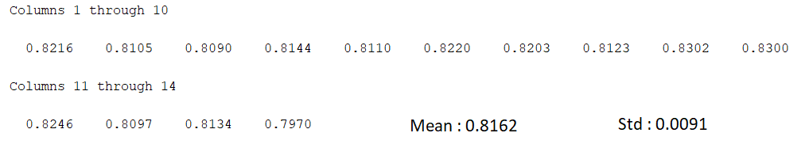  
*Fig 3.*

Qualitative:

Below are ITK snaps for Images with index 11 and 36 ( index 11 has the pre-best similarity and 36 had the worse ) compared to the reference 12

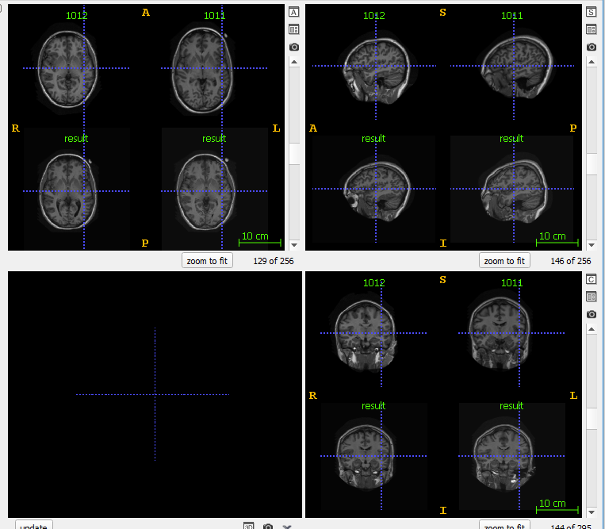

*Fig 4. Results of Image 11. result to the left is affine only and to the right is the final result*

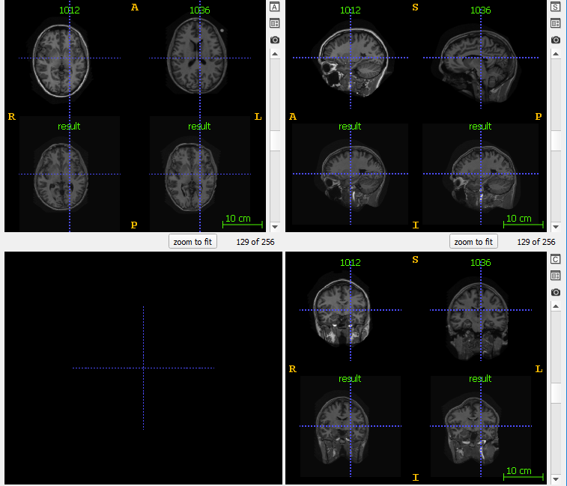

*Fig 5. Results of Image 36. result to the left is affine only and to the right is the final result*

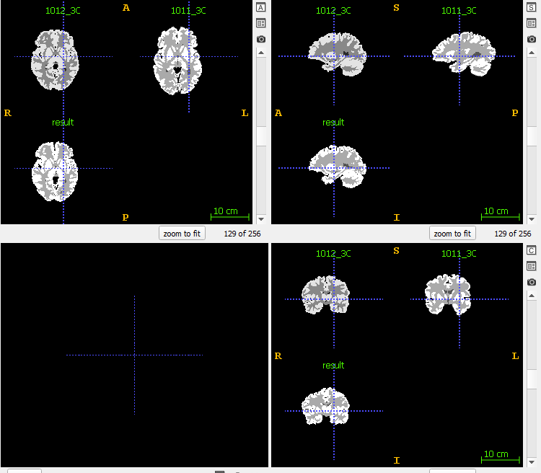

*Fig 6. Results of Label 11*

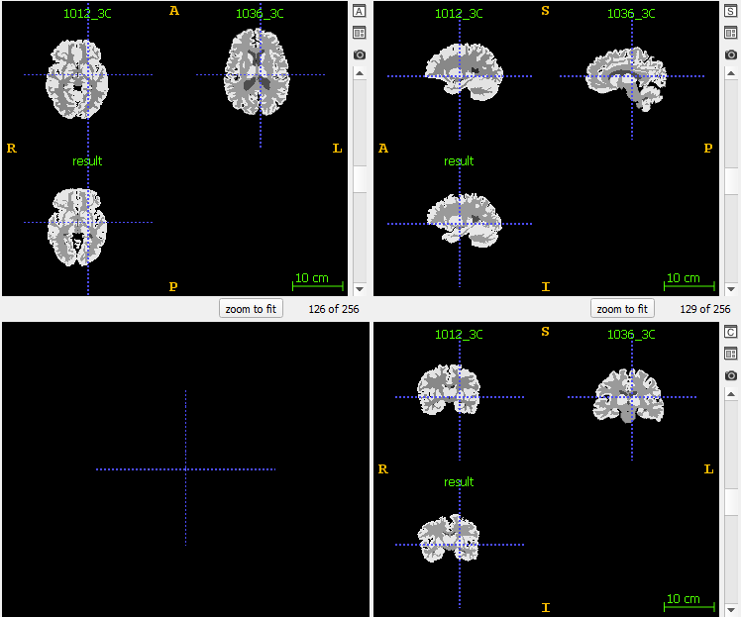

*Fig 7. Results of Label 36*

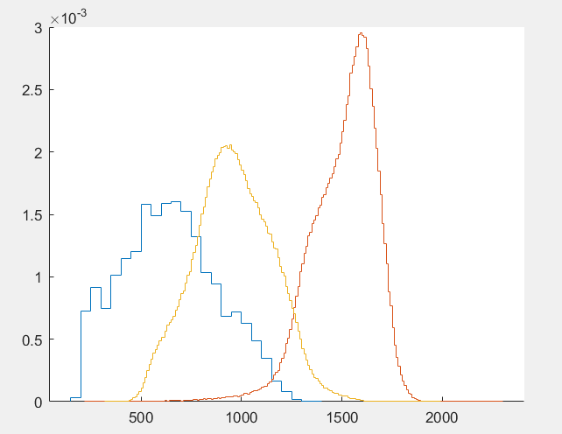  
*Fig 8. Tissue Models*

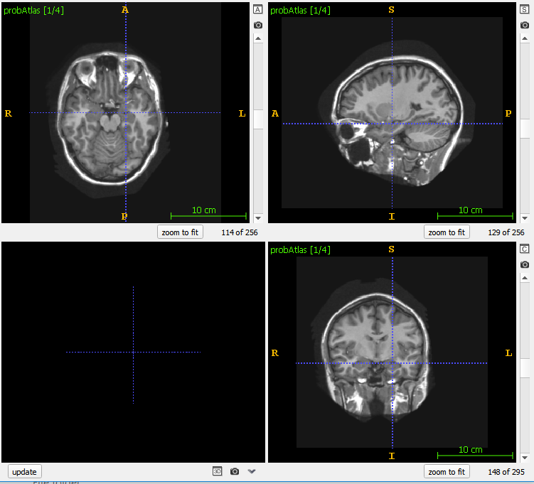  
*Fig 9. Probabilistic atlas Intensity Image*

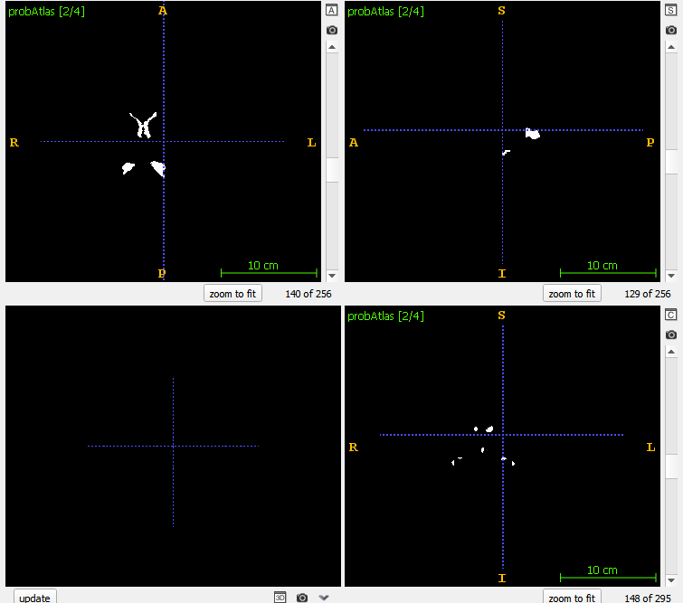  
*Fig 10. Probabilistic atlas CSF*

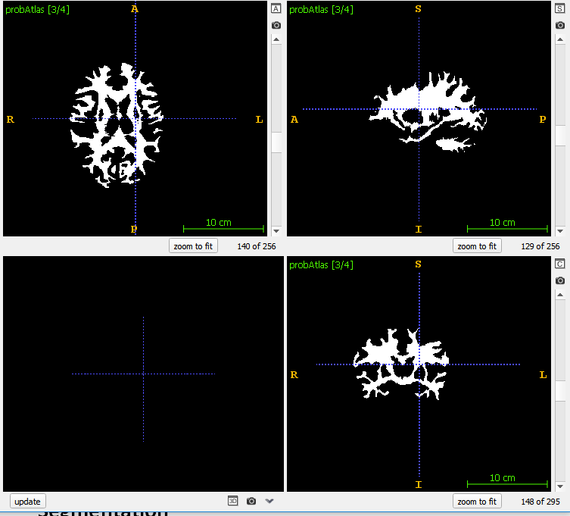

*Fig 11. Probabilistic atlas Gray Matter*

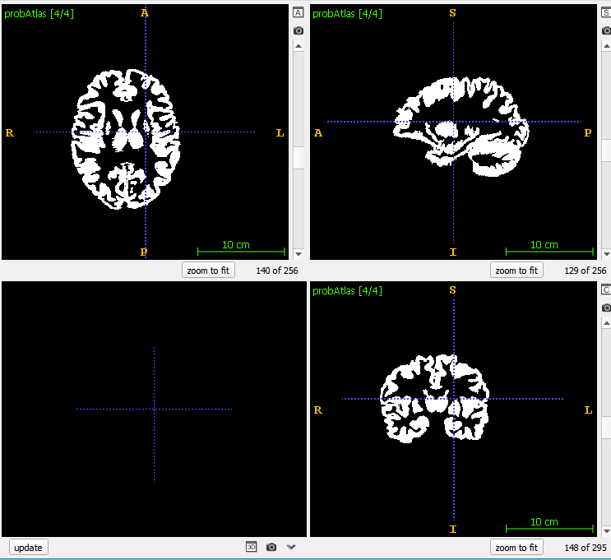

*Fig 12. Probabilistic atlas White Matter*

Lab 02 - MISA  
Probabilistic Atlas + EM

Segmentation

**Manual:**

File in MATLAB:

propagateAtlas.m : is the code for label propagation and saves its results to folder named results1

tissueModels.m : is the code for applying tissue Models segmentation. It saves its files in folder named results2

TissueModelsFunction.m : is the function used to generate the mapping table of tissue models of atlas.

propagateTissueModels.m : is the code for applying both tissue models and label propagation. It saves its results in folder named results3

testResults.m : is used to test the results of our segmentation for the three methods, label propagations , Tissue models and both together.

setInfo.m : this function is used to modify the meta data of Nifti file.

For EM documentation : use the same documentation for EM with three initialization methods were added and a parameter ‘combined’ was added used to combine the results of EM with atlas from inside.

Important Notes: to use any code modify the path of your data only ( by data we mean the training Images and Masks )

Also modify the path for a reference Nifti file. This reference was used so that MATLAB saves Nifti Images in the same manner of data we have ( orientation , pixelDimension …)  
info3 variable is used as reference for 3D Nifti and info4 for 4D Nifti ( ex: Atlas ).

**Discussion:**

**Note that all Quantitative results are shown in table in fig 22,23,24**

*1.1* **Tissue Models:**

A table was created to map the distribution of labels in the atlas to the target Image. As we will see in the results, it wasn’t the best method since as we can see in fig 9 the values indicated by arrows represent an error that we will always see and it will never converge to the best segmentation. In our case we will see that there were always a tissue that acted as a recessive, and this was fixed later using weights.

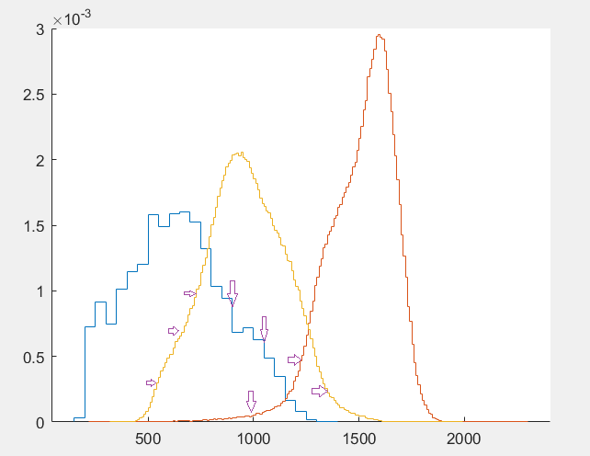  
*Fig 13.*

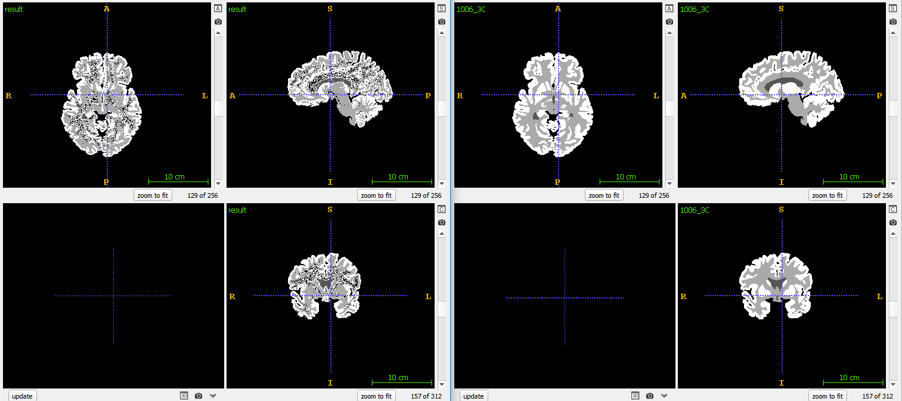

*Fig 14 Image 6 - Tissue Models - Left Segmented Result - Right Ground Truth*

*1.2* **Label Propagation:**

The results came much better than tissue models, in fact this method has results near to EM+Atlas. But Label propagation does depend directly on the registration method we used. In this approach we transformed the segmented atlas, not each class alone.

For this we used the files for labels with probabilities multiplied by 15000 and then later normalized back to a probability, and this is for the purpose of good registration.

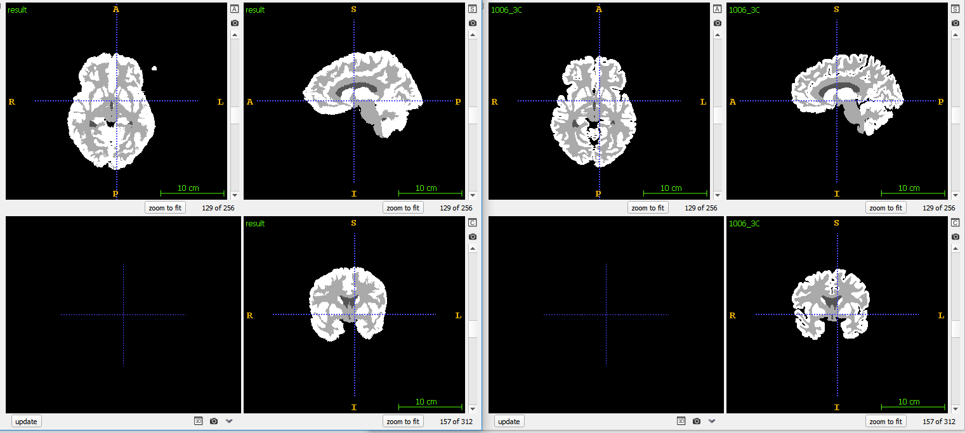  
*Fig 15. Image 6 - Label propagation - Left Segmented Result - Right Ground Truth*

*1.3* **Label Propagation + Tissue Models:**

The results came quite good , where the errors produced by tissue models were fixed by the spatial information. The probabilities from both methods were combined in equal weights ( this is mentioned since this was enhanced later ) .

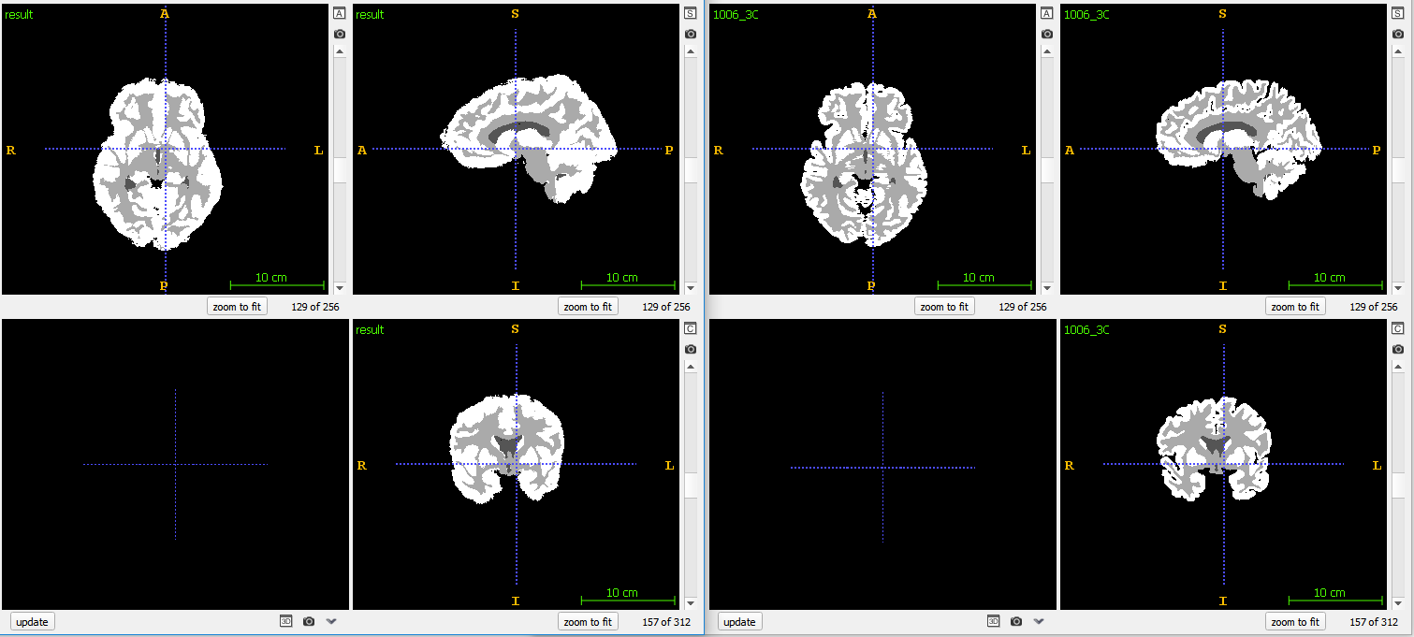

*Fig 16. Image 6 -Label Propagation+Tissue Models - Left Segmented Result - Right Ground Truth*

*2.1* **EM with K-Mean initialization:**

This approach was discussed in the lab before, but worth to mention that all methods depending on tissue intensity information only did not lead to good results.It has been recognized that with inappropriate initialization there is sometimes a class that is being almost eliminated.

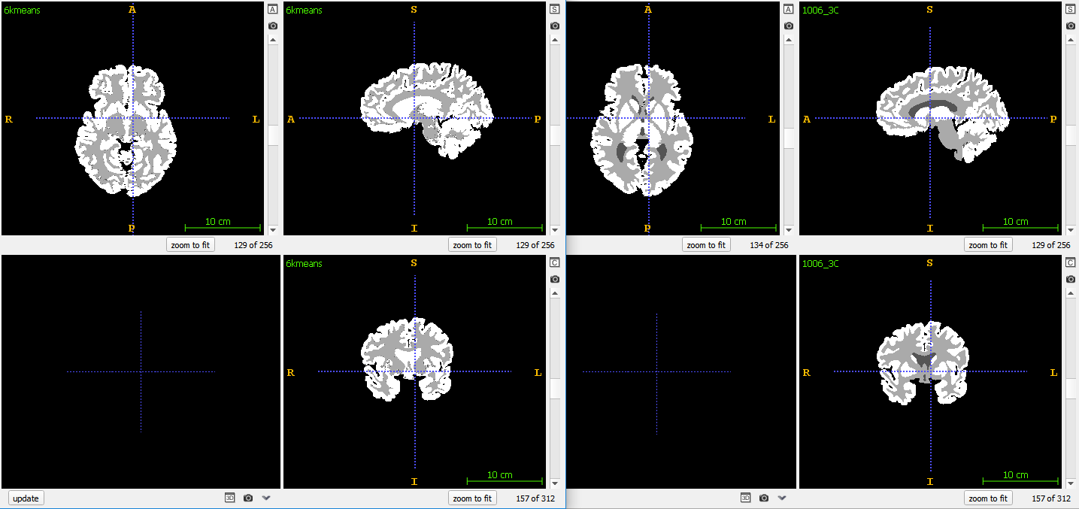  
*Fig 17. Image 6 - EM Kmean initialized - Left Segmented Result - Right Ground Truth*

*2.2* **EM with tissue models initialization:**

The method of initializing EM with tissue models enhanced our result and guaranteed a good starting point towards our goal.

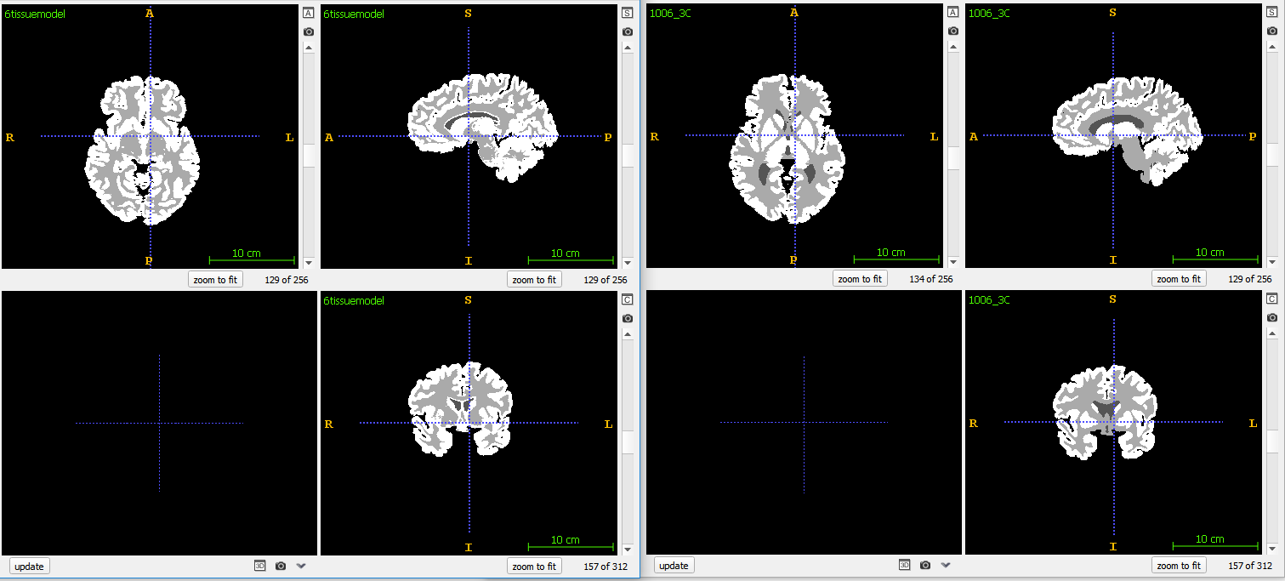  
*Fig 18. Image 6 - EM Tissue model initialized - Left Segmented Result - Right Ground Truth*

*2.3* **EM with label propagation initialization:**

Using a label propagation with EM was a good approach but only to a limit where EM can not go beyond.This could be a good approach since we are using spatial information as a start up and then using the intensity info to proceed with classification.

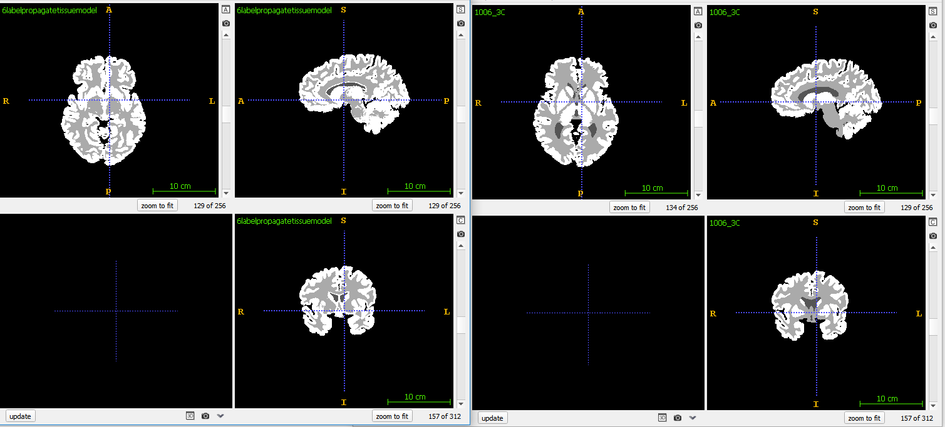  
*Fig 19. Image 6 - EM Label propagation initialized - Left Segmented Result - Right Ground Truth*

*3* **Choosing the best approach:**

Since Label propagation + Tissue Models was the best approach of atlas, it was convenient to combine it with EM. For this purpose a probability Image of each class was created ( in directory results3 ), and those Images were used at each step along with the mvnpdf at each iteration. It was clear that the results were good and less iterations were needed. However it was noted that from all intensity distribution methods a class needed to be focused on more, and this is were we introduced three weights added to the label propagation + tissue models. We tried several parameters and we choose one, but such approach could be enhanced perhaps by adding an optimizer and finding the best values for the weights w1, w2 and w3 ( this will be investigated in the project ). It was noted that using the weights significantly improved the results.

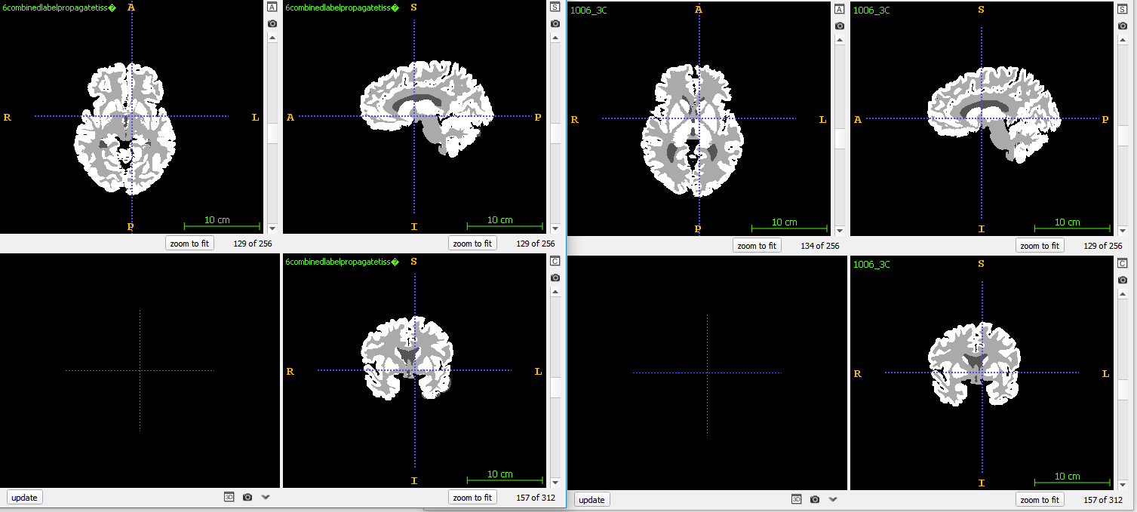  
*Fig 20. Image 6 - EM + Atlas - Left Segmented Result - Right Ground Truth*

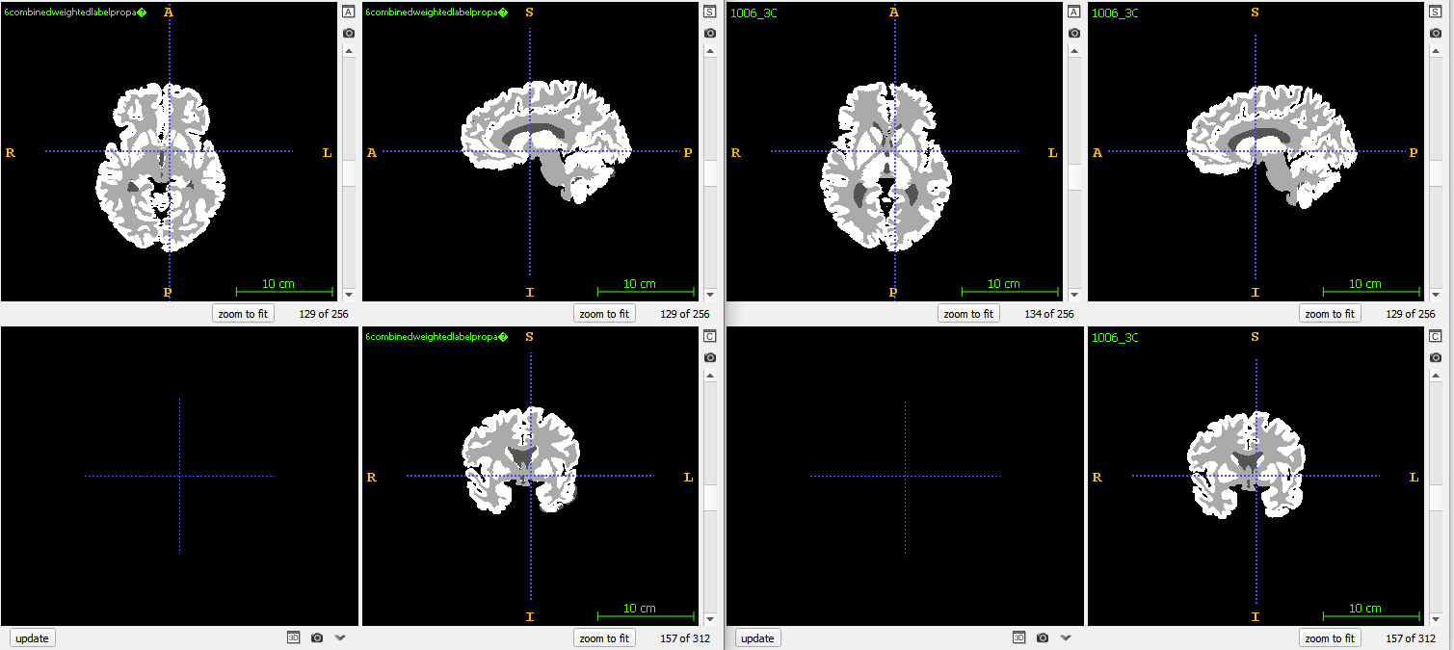  
*Fig 21. Image 6 - EM + Atlas Weighted - Left Segmented Result - Right Ground Truth*

*Table of Results:  
you can find detailed [here](results1.xlsx)*

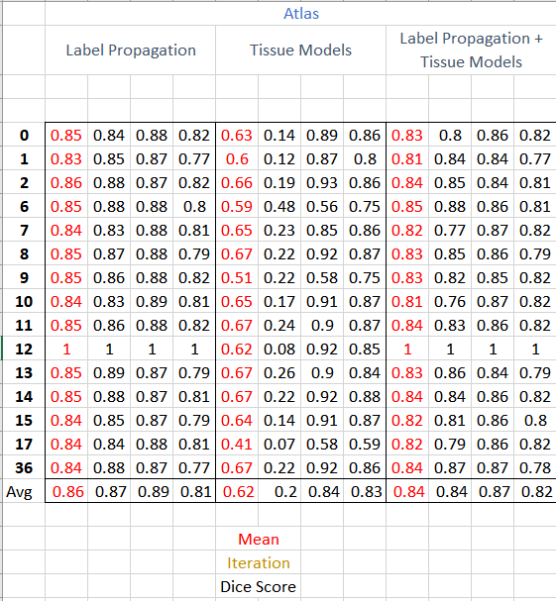

*Fig 22. Atlas segmentation Results*

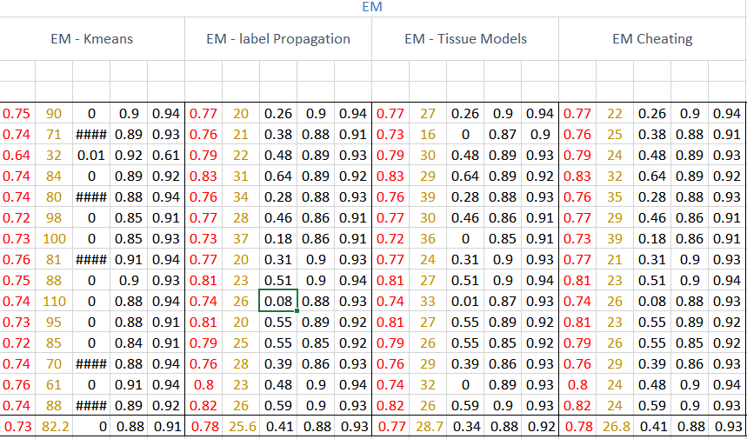  
*Fig 23. EM Segmentation Results*

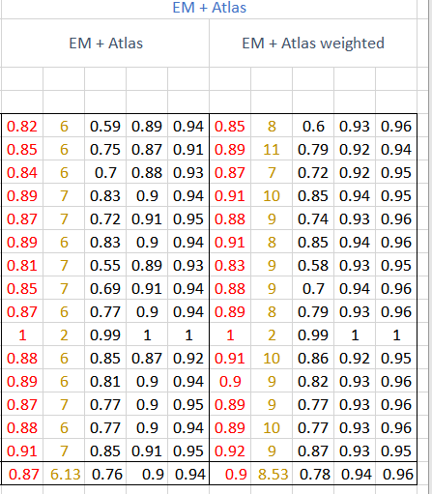  
*Fig 24. EM + Atlas Segmentation Results*

***Thank you!***